Logical function D has 4 variables Q1, Q2, Q3, Q4 which is given in truth table:

|  |  |  |  |  |  |  |  |  |  |
| --- | --- | --- | --- | --- | --- | --- | --- | --- | --- |
| № | Current state | | | | № | Next state | | | |
|  | Q1 | Q2 | Q3 | Q4 |  | D1 | D2 | D3 | D4 |
| 0 | 0 | 0 | 0 | 0 | 2 | 0 | 0 | 1 | 0 |
| 2 | 0 | 0 | 1 | 0 | 3 | 0 | 0 | 1 | 1 |
| 3 | 0 | 0 | 1 | 1 | 5 | 0 | 1 | 0 | 1 |
| 5 | 0 | 1 | 0 | 1 | 7 | 0 | 1 | 1 | 1 |
| 7 | 0 | 1 | 1 | 1 | 8 | 1 | 0 | 0 | 0 |
| 8 | 1 | 0 | 0 | 0 | 6 | 0 | 1 | 1 | 0 |
| 6 | 0 | 1 | 1 | 0 | 14 | 1 | 1 | 1 | 0 |
| 14 | 1 | 1 | 1 | 0 | 0 | 0 | 0 | 0 | 0 |

Sequence:

|  |  |  |  |  |  |  |  |
| --- | --- | --- | --- | --- | --- | --- | --- |
| 0 | 2 | 3 | 5 | 7 | 8 | 6 | 14 |

Logical function, which can provide this sequence:

$$D_{1}={\overline{Q}}_{1}Q_{2}Q_{3}$$

$$D_{2}={\overline{Q}}_{1}{\overline{Q}}_{2}Q_{3}Q_{4}+Q_{1}{\overline{Q}}_{2}{\overline{Q}}_{3}{\overline{Q}}_{4}+{\overline{Q}}_{1}Q_{2}Q_{3}{\overline{Q}}_{4}+{\overline{Q}}_{1}Q_{2}{\overline{Q}}_{3}Q_{4}$$

$$D_{3}=Q_{1}{\overline{Q}}_{2}{\overline{Q}}_{3}{\overline{Q}}_{4}+{\overline{Q}}_{1}Q_{2}{\overline{Q}}_{3}Q_{4}+{\overline{Q}}_{1}{\overline{Q}}_{2}{\overline{Q}}_{4}+{\overline{Q}}_{1}Q_{3}{\overline{Q}}_{4}$$

$$D_{4}={\overline{Q}}_{1}Q_{2}{\overline{Q}}_{3}Q_{4}+{\overline{Q}}_{1}{\overline{Q}}_{2}Q_{3}$$

Input signal will receive by means of port P1:

|  |  |  |  |  |  |  |  |
| --- | --- | --- | --- | --- | --- | --- | --- |
| P1.7 | P1.6 | P1.5 | P1.4 | P1.3 | P1.2 | P1.1 | P1.0 |
| x | x | x | x | Q4 | Q3 | Q2 | Q1 |

Output signal will receive by means of port Р3:

|  |  |  |  |  |  |  |  |
| --- | --- | --- | --- | --- | --- | --- | --- |
| P3.7 | P3.6 | P3.5 | P3.4 | P3.3 | P3.2 | P3.1 | P3.0 |
| x | x | x | x | D4 | D3 | D2 | D1 |

**Schematic diagram**

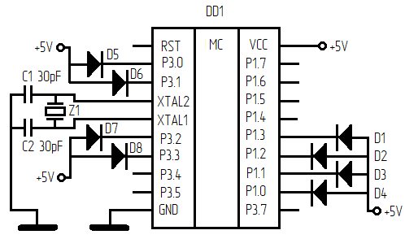

(D1-D8 – LED)

Circuit was assembled to look on switched off LED. Program by turns will compute logical operation on each pin.

Total 117 machine cycles. If microcontroller frequency was 12 MHz it will take 117 μs or if 24 MHz only 59 μs (maximum supportable frequency).

If you create your logic function it might be faster or slower.